Title of the game: In mom's kitchen
Teacher's name: Tsvetelina Atanasova 66 "Elitsa" Pancharevo
- General aim of the game:
Children get to know different cuisines through canned food and share tastes from different combinations. They select the ingredients in several groups - compote, jam, tomato paste with peppers. The different ingredients that can be included in each group are defined.

- Age range addressed: 5-6 years old.
- Robot that can be used for this game: The robot that learns and combines flavors together with children!
Doc. SuperDoc, Mind, Bee BOT and/or any kind of simple robot -

- Link to the game instructions and game-boards to be printed:

Description of the board
The game Board consists of 30/30-20 square soft puzzle-type boards. The pictures of food products - fruits and vegetables are arranged on it randomly. Participants move the robot along the board and combine the ingredients.

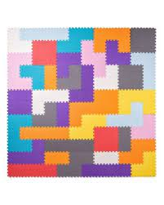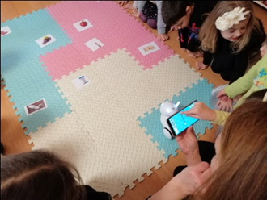
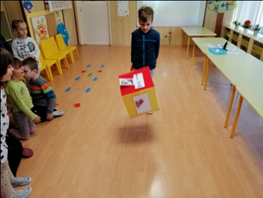
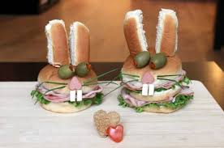

Other useful materials
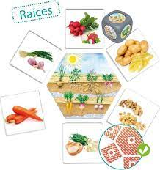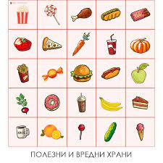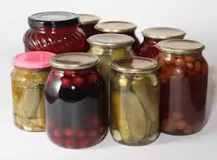

- Dice, on which countries there are images of different types of food products - fruits and vegetables, and the country from which the products come.
- Canned food - jam, cucumbers, compote, etc.

Phases of the game
- Preparation:
The teacher offer to children to compare the groups of fruits and vegetables by taste, by, forms, by colours and asks them do they use them at home cousine? Then all group brainstorms to find out which of them are suitable for preservation in the groups - compote, jam, pickle, sauces,etc. They know the taste of canned food and its appearance.
The children discuss in which family what is canned and what is cooked from the canned food.
- Start of the game:
The children are in a group gathered around the game board. They have participation numbers drawn from slips of paper. Participant number 1 is the first to roll a die with product images stuck on it.

c. Core phase of the Game
After throwing the dice, the child directs with the Robot to the image on the playing field with the same product and, reaching it, takes it and places it on one of the three cans - compote, pickle or jam. The game starts over from the next player.

- Conclusion:
The game provides positive emotions to children without forcing them to compete, every child finds expression and feels satisfied with the work done and the knowledge shown.

Variants: The game can also be constructed according to other knowledge and interests of children of the same age group.

In mom's kitchen
Teacher's name: Tsvetelina Atanasova – Preprimary School 66 "Elitsa"- Pancharevo

