Teacher’s name: Pavlina Kazakova – 182 Preschool and kindergarten “ Bee” - Pasarel
- Title of the game : Let's count to 5

General aim of the game:
- During the game, children master skills:
- 1. To guide and manage RoBy along a chosen route.
- 2. To count to 5 in a straight line and to count objects to 5.
- 3. To orient themselves in the main directions - forward, backward, left, right.
- 4. To determine the location of an object.
- Age range addressed: 5 years old.
- Robot that can be used for this game: MIND Clementoni robots.
- Link to the game instructions and game-boards to be printed:

Description of the board:
The playing field consists of cells arranged in 4 rows and 6 columns. The cells are squares with a side of 15 cm. Cards with pictures of food products are placed in several cells. START is marked in the upper left corner /снимка 1/.

Other useful materials: 1. Food cards for the playing field /photos 2-8. 2. Cards with numbers from 1 to 5. The field of cards with numbers is divided into 2 parts. The number is marked in the upper part, and points are marked in the lower part /photo 13/.

Phases of the game:
- Preparation:
In advance, the topics are discussed with the children:
1. Why is it necessary to study mathematics?
2. What is a healthy diet?
The cards with the numbers from 1 to 5 are placed on the table.
The playing field with the cards on which the food products are depicted is placed on the floor.

Start of the game:
1. All children participate in the game, divided into 2 teams of 5 children each.
2. Each team arranges the cards with the numbers from 1 to 5.
3. The robot is placed on the START field.
4. One of the teams stands next to the playing field and with ROBY they start the game.

c. Core phase of the Game
The game takes place in 3 parts:
1. Counting to 5: The teacher focuses the children's attention on the table with cards and sets the task of arranging them in sequence. The first team puts the cards in order. /снимка 9/. The first team arranges the cards sequentially from 1 to 5. After it - the second team.
2. Healthy eating: On the playing field, each team needs to choose 5 products to make a sandwich. The robot is launched at START. The first child from a team chooses one product, the second - chooses 1 product as well, etc. until 5 products are selected. The other team works in the same sequence /снимка 10/.
3. Броене на продуктите: Децата подреждат под цифрите /1-5/, продуктите, които са избрали. Всяка цифра определя последователността на продукта при приготвяне на сандвича /снимки 11-12/.

d. Conclusion:
Children are able to:
- operate a robot and manage it along a selected route;
- count from 1 to 5 in a straight line and count products/items/;
- determine the location of an object and orientate in the main directions /forward, backward, left, right/.

Variants
The game can be used to learn other num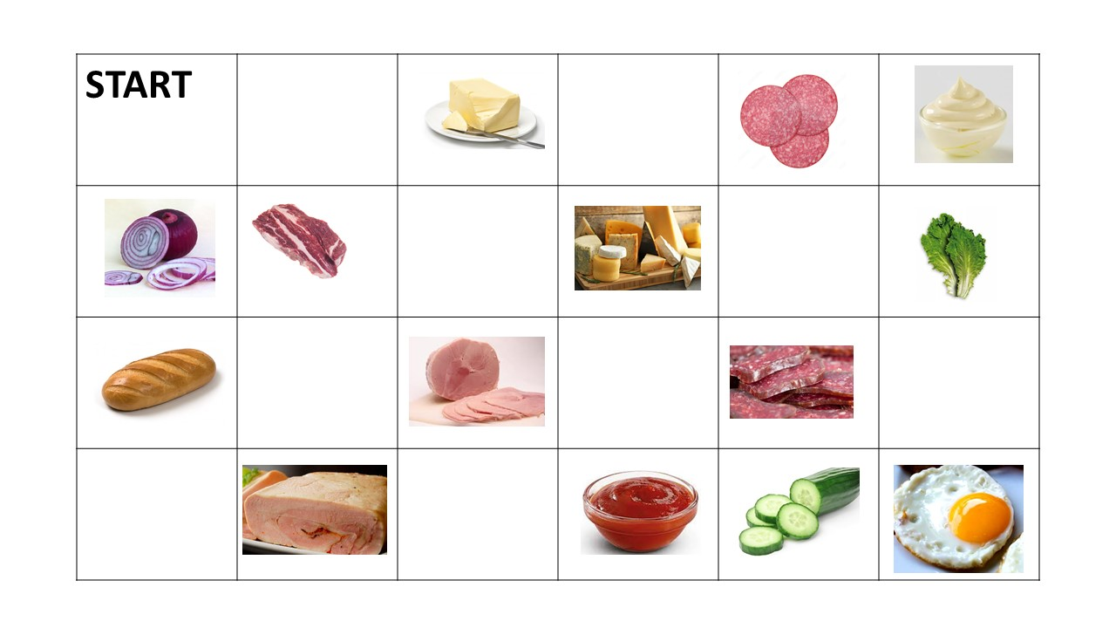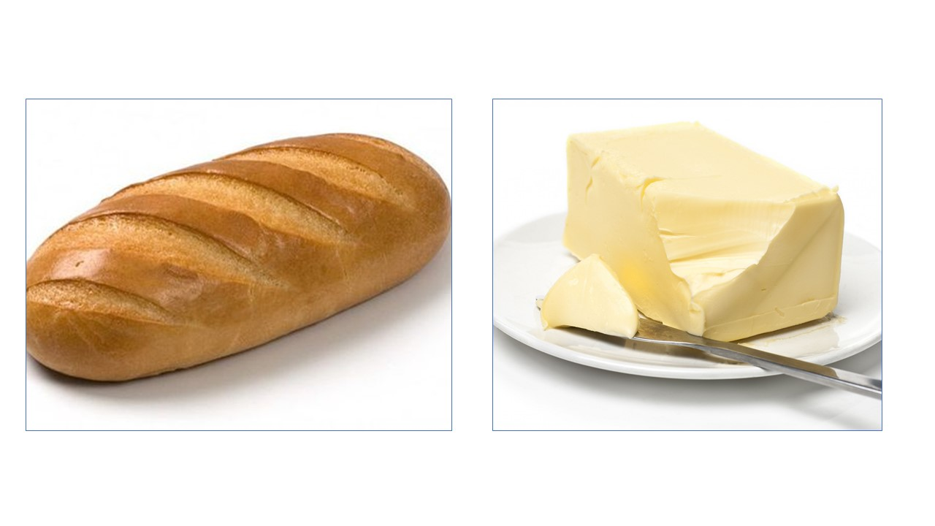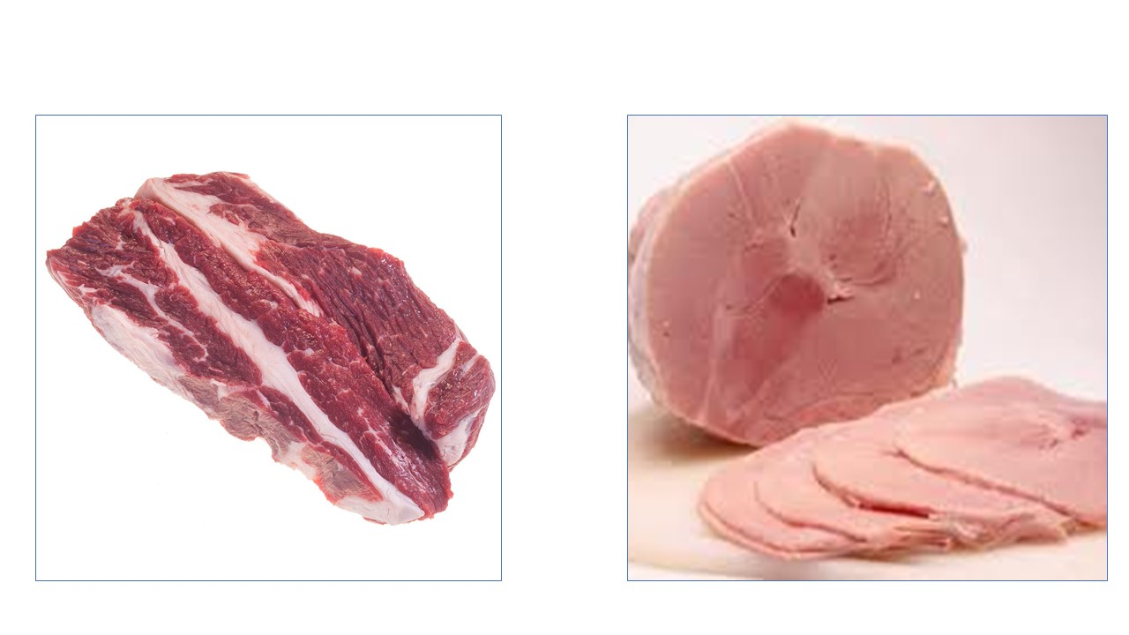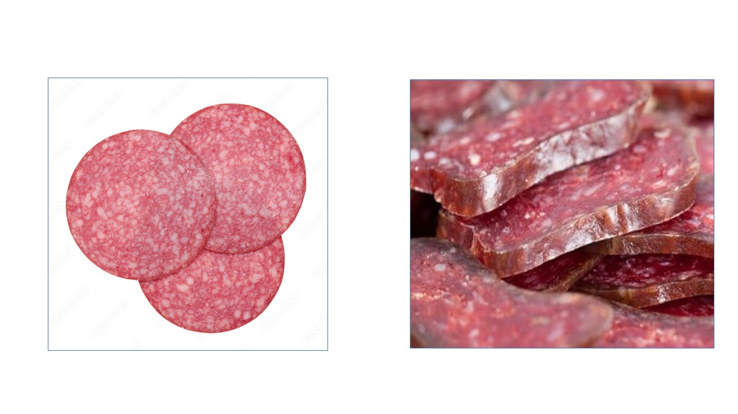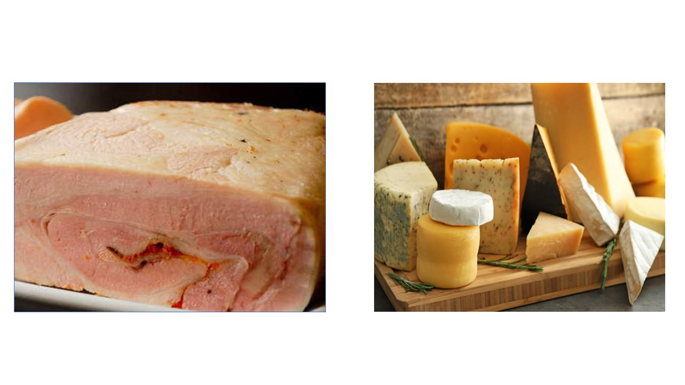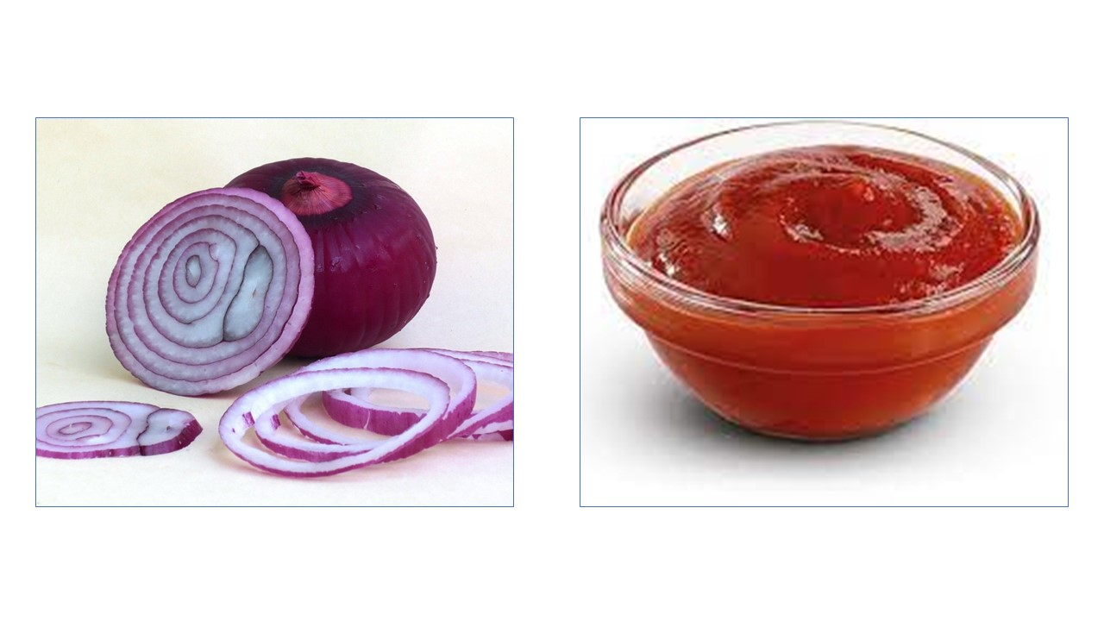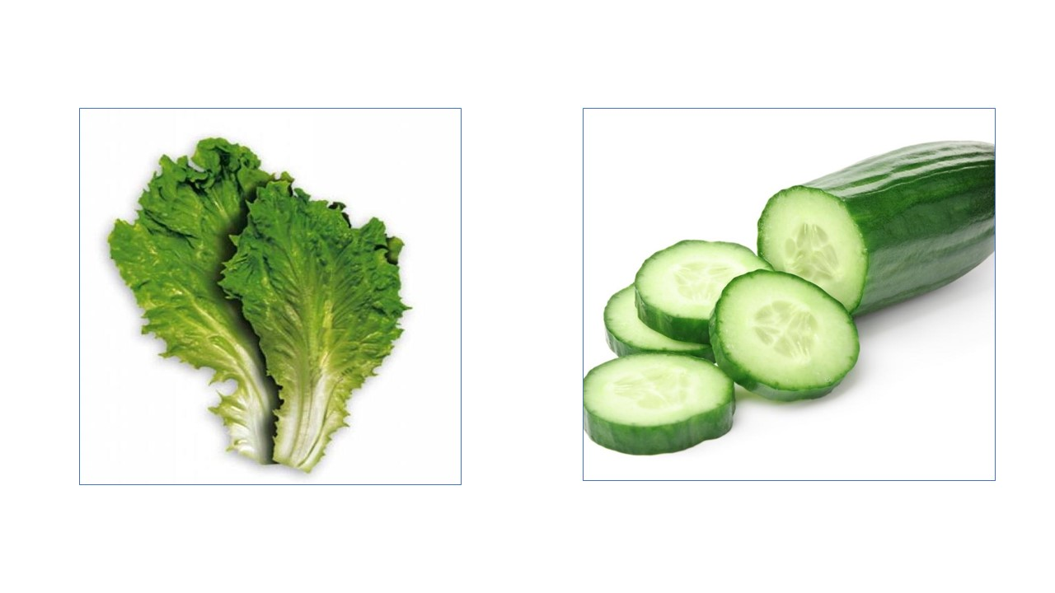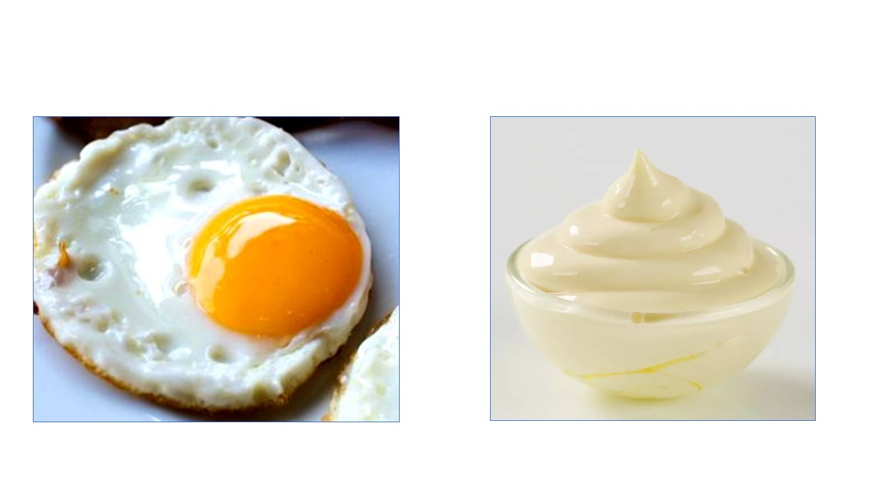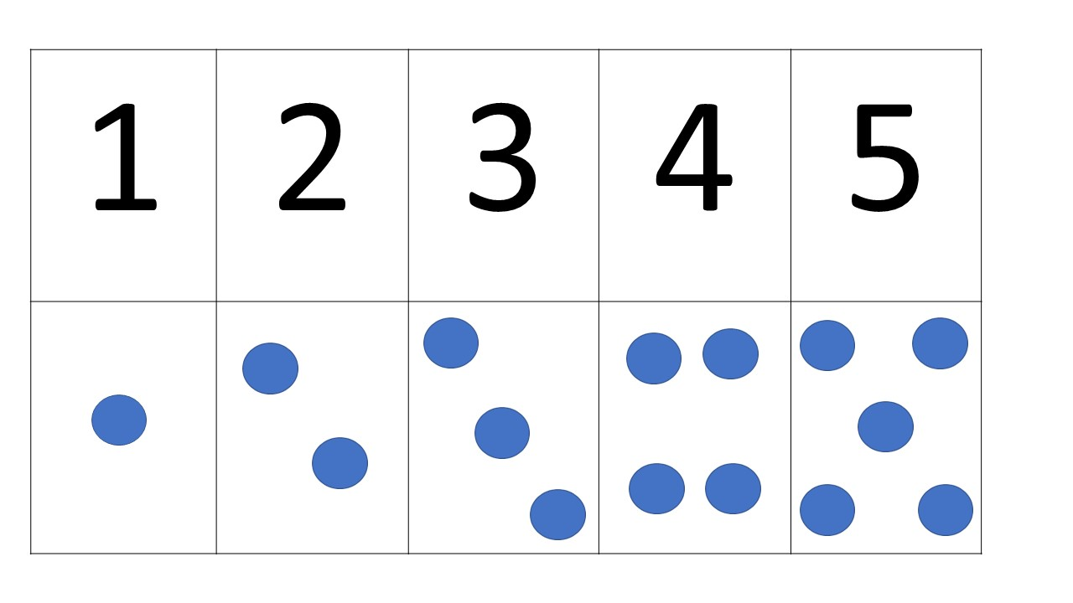bers and to make other menus for healthy eating.

