Teacher’s name: Polina Kostova – 66 Preschool and kindergarten “ Elitsa” - Pancharevo

Title of the game : In Space - Lunar Station
- General aim of the game:
- During the game, children build spatial orientation and network orientation skills; They make independent decisions in their choices to achieve the goal; they work in a team.
- 2. Development of children in the field of robotics and learn about space. The situation challenges children to focus on solving problems using technology and science as tools.
- 3. Arousing children's curiosity about space and children's exploratory spirit - "Being an inventor is easy!".
- Age range addressed: 6 -7 years old
- Robot that can be used for this game: MIND Clementoni robots / A living robot-child in a suit/
- Link to the game instructions and game-boards to be printed:

Description of the board:
A grid of squares in 6 rows and 6 columns is drawn on the floor, which is used to move the robot./снимка 1/

Other useful materials: Други полезни материали:
A set algorithm on a piece of paper. /снимкa/ 2
A living robot child in a suit. A child astronaut in a suit. Rocket-kid in a suit./снимка 3/

Phases of the game:
- Preparation:
Arousing children's curiosity about space and children's exploratory spirit - "Being an inventor is easy!". Robot, astronaut and rocket costumes are pre-made from recycled materials.
- Start of the game:
The astronaut receives a sheet with a set algorithm to move the robot from START to END, where the rocket is located. The astronaut and the robot stand on START and the game begins.
c. Core phase of the Game / Основна фаза на играта
1. The game introduces children to the mysterious Space.
2. The goal is for the astronaut and the robot to reach the rocket according to a mapped algorithm, following the correct steps. The astronaut touches the robot from the front on the chest, from the back on the back, on the left shoulder, and on the right shoulder. Through these touches, the robot moves correctly along the circuit.
3. They reach the moon with the rocket. There they build a Moon Base where they collect moon rocks and sand. /снимка 4/

d. Conclusion: / Заключение:
The game is very emotional. Everyone involved in the situation wants to be a NASA astronaut and a robot to reach the rocket and reach the moon. /снимка 5.
Под формата на игра децата разбират езика на алгоритмите и се запознават с прости логически функции. Алгоритъмът по който се придвижва робота е труден, но с общи усилия децата се справят и доказват, че може да има колаборация между тях, а не съревнование.
В играта се опират на сетивата си и разбират разликата между човек и машина.

Variants
В играта детето-робот може да бъде заменено с истински робот. Мрежата и описанието на играта могат да бъдат използвани без да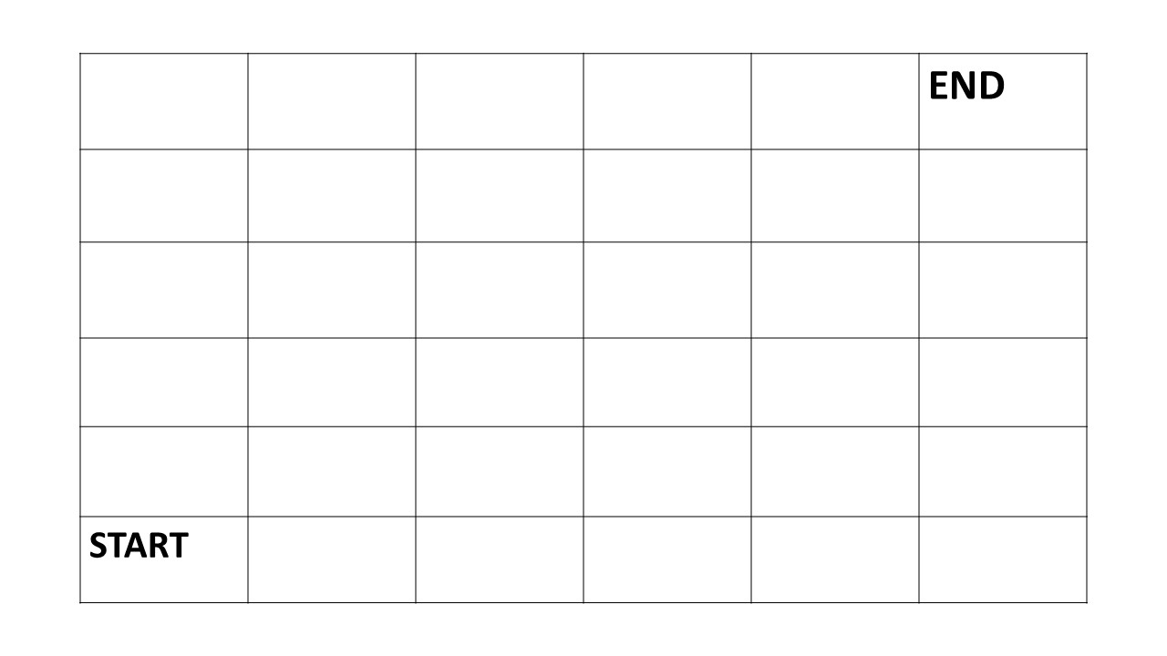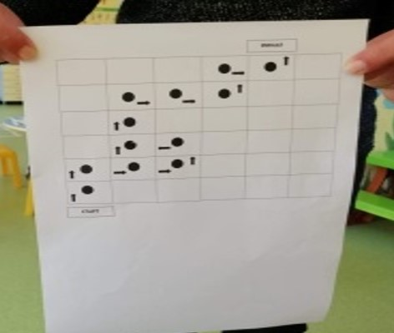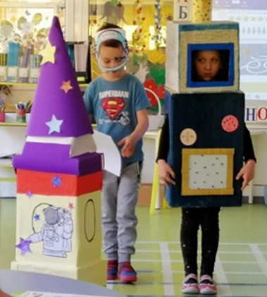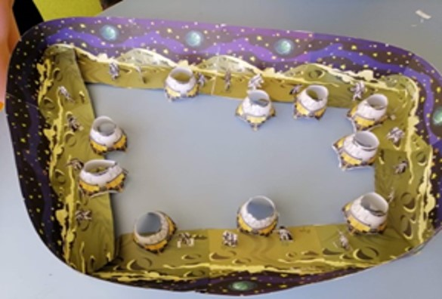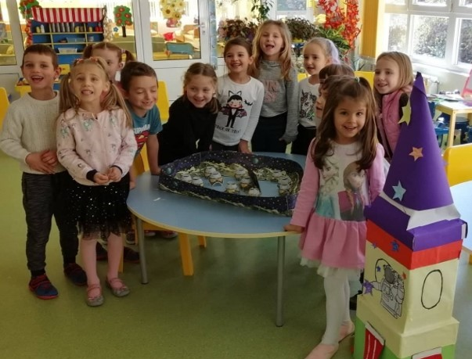 се променят.

